**EX 2-1 #7:**

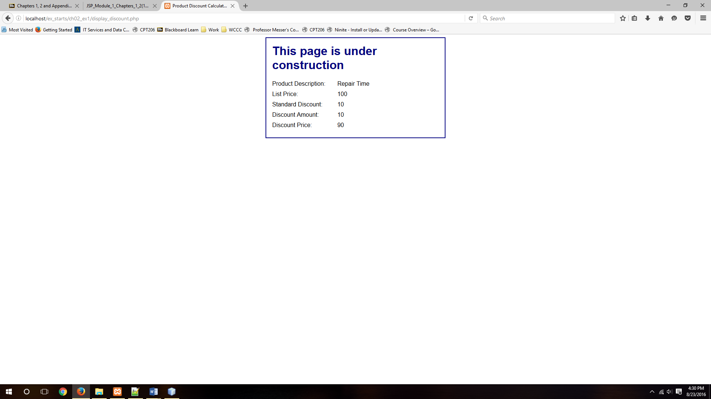

This displays the calculated data properly, but is unformatted as it should be for this step.

**EX 2-1 #8:**

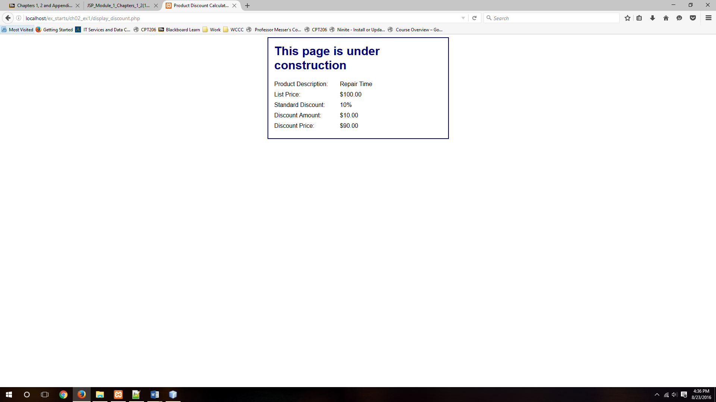

Calculations are accurate and formatted properly.